Unit 3 : Biodiversity and its conservations:

Biodiversity, a shortened form of Biological diversity, refers to the existence of number of different species of plants and animals in an environment.

The Convention on Biological Diversity (1992) of the United Nations gives a formal definition of biodiversity in its Article 2: "Biological diversity means the variability among living organisms from all sources including, inter alia, terrestrial, marine, and other aquatic ecosystems and the ecological complexes of which they are part; this includes diversity within species, between species and of ecosystems."

Biodiversity is also defined as the existence of variability among living organisms on the earth, including the variability within and between species, and within and between ecosystems.

Species Diversity

Species diversity refers to the variety of different species of plants, animals, fungi, and organisms that are present in a region. It is estimated that there are above 30 million species on the earth. Species diversity is a part of diversity. Even within a small pond, we can notice a great variety of species. Species diversity differs from ecosystem to ecosystem. For example, in a tropical ecosystem more diversity is found than in temperate ecosystem. The most diverse group of species is invertebrates - animals without backbones.

At present, conservation scientists have been able to identify and categorize about 1.8 million species on earth. Many new species are being identified. Areas that are rich in species diversity are called ‘hotspots’ of diversity.

Genetic Diversity

It is the variation in genes that exists within a species. Genetic diversity corresponds to the variety of genes contained in plants, animals, fungi, and micro-organisms. It occurs within a species as well as between species. For example, poodles, German shepherds and golden retrievers are all dogs, but they all are different in look, color, and abilities. Each human being is different from all others. This genetic variability is essential for a health breeding of a population of species.

The diversity in wild species make the ‘gene pool’ from which crops and domestic animals have been developed over thousands of years.

Ecosystem Diversity

It is the diversity of ecosystems, natural communities, and habitats. In other words, ecosystem diversity refers to the variety of ways that species interact with each other and their environment. Tropical or temperate forests, grasslands, hot and cold deserts, wetlands, rivers, mountains, and coral reefs are instances of ecosystem diversity.

Each ecosystem corresponds to a series of complex relationships between biotic (living) and abiotic (non-living) components.

Value & Productive Use of Biodiversity

The importance of biodiversity is second to none. It boosts the ecosystem of productivity where each species, irrespective of their size, have an important role to play. Greater diversity in species ensure natural sustainability for all life forms. Hence, there is a need to preserve the diversity in life on the earth.

According to the UN sources at least 40 percent of the world’s economy and 80 percent of the needs of the poor are derived from biological resources. In addition, the richer the diversity of life, the greater the opportunity for medical discoveries, economic development, and adaptive response to such new challenges as climate change.

Significance of Biodiversity

Environmental services from species and smooth running cycles of ecosystems are necessary at global, regional, and local levels.

Biodiversity is essential for maintaining the water cycles, production of oxygen, reduction in carbon dioxide, protecting the soil, etc. It is also essential for preserving ecological processes, such as soil formation, circulation of and cleansing of air and water, global life support, fixing and recycling of nutrients, maintaining hydrological balance within ecosystems, maintaining rivers and streams throughout the year, etc.

Biodiversity has many values such as consumptive use value, productive use value, social values, ethical and moral values.

A healthy biodiversity offers many valuable services as follows.

* The more a region is rich in terms of biodiversity, better is the regulation of the different cycles. For example, forests regulate the amount of carbon dioxide in the air by releasing oxygen as a by-product during photosynthesis, and control rainfall and soil erosion.
* Protects water resources from being depleted, contaminated, or polluted.
* Helps in soil formation and protection.
* Helps in nutrient storage and recycling.
* Helps check pollution.
* Contributes to climate stability.
* Helps an ecosystem in recovery from unpredictable events.
* Provides biological resources such as food, medicinal resources, and pharmaceutical drugs, wood products, ornamental plants, breeding stocks, etc.
* Provides recreation and tourism facilities.
* Helps in research, education, and monitoring.
* Preservation of biological resources is essential for the well-being and long-term survival of mankind.

Productive Use Value of Biodiversity

Productive Use Value refers to the commercial value of products that are commercially harvested for exchange in formal markets.

Modern civilization is invariably a gift of biodiversity. The food we eat, the medicine we take in, the furniture we use, the industries, for example, are derivatives of biological diversity.

The agricultural crops of the present day have originated from wild varieties. Biotechnologists use the wild plants for developing new, high-yielding, and pest or disease resistant varieties. Biodiversity is home to original stock from which new varieties are being developed.

Similarly, all our domesticated animals came from their wild-living ancestral species. With the help of scientific breeding techniques, animals giving better yield of milk, meat, etc. are being developed. The animal products used by modern society come from the advances made in the fields of poultry farming, pisciculture, silviculture, dairy farming, etc.

Fossil fuels, considered to be pivotal in modern society, such as coal, petroleum, and natural gas are gifts of biodiversity from the geological past.

Most of the pharmaceutical drugs and medicines used in the present time are extracted from different plants.

Biodiversity provides rich storehouse for industrialists and entrepreneurs to develop new products. It provides agricultural scientists and biotechnologists with ample scope for developing new and better crops. New crop varieties are being developed using the genetic material found in wild relatives of crop plants though biotechnology.

The need of the hour is the preservation of biodiversity for industrial, economic, and above all, environmental safety. This is called ‘biological prospecting’.

The Earth’s biodiversity is evenly distributed across its surface. There are over a thousand major eco-regions in the world. It is estimated that there are about 200 richest, rarest and most distinctive natural areas in the world. These are referred to as the Global 200.

Hotspots of biodiversity refer to bio-geographic regions where significant levels of biodiversity with richness and unusual concentration of endemic species are found, however, they are threatened with mindless exploitation and destruction.

A biodiversity is termed as a hotspot if −

* It has at least 1,500 vascular plants as endemic.
* It must be threatened or under threat of destruction to a considerable extent.

Across the world, about 35 areas are marked as hotspots of biodiversity and they represent 2.3 percent of the Earth’s land surface but they support more than half of the world’s endemic plant species and almost half of birds, mammals, reptiles, and amphibians as endemic.

## List of Biodiversity Hotspots in the World

North and Central America − California Floristic Province, Madrean pine-oak woodlands, Mesoamerica

The Caribbean − Caribbean Islands

South America − Atlantic Forest, Cerrado, Chilean Winter Rainfall-Valdivian Forests, Tumbes-Chocó-Magdalena, Tropical Andes

Europe − Mediterranean Basin

Africa − Cape Floristic Region, Coastal Forests of Eastern Africa, Eastern Afromontane, Guinean Forests of West Africa; Horn of Africa; Madagascar and the Indian Ocean Islands; Maputaland-Pondoland-Albany; Succulent Karoo

Central Asia − Mountains of Central Asia

South Asia − Eastern Himalaya, Nepal; Indo-Burma, India and Myanmar; Western Ghats, India; Sri Lanka

South East Asia and Asia-Pacific − East Melanesian Islands; New Caledonia; New Zealand; Philippines; Polynesia-Micronesia; Southwest Australia; Sundaland; Wallacea

East Asia − Japan; Mountains of Southwest China

West Asia − Caucasus; Irano-Anatolian

About 1.8 million species are known to mankind at present. Scientists, however, have estimated that the number of species of plants and animals on the earth can go up to 20 billion. It means a majority of species still remain undiscovered.

World’s most prolific bio-rich nations are in the south. On the other hand, the majority of the countries capable of exploiting biodiversity are the developed Northern countries. These countries have very low level of biodiversity.

Developed nations want to consider biodiversity as ‘global resources’. However, nations rich in biodiversity like India don’t want to compromise their sovereignty over their biological diversity unless there is a revolutionary change in global thinking about sharing of all types of natural resources such as rare minerals as uranium, oil, or even intellectual and technological resources.

India is home to rich biodiversity. Countries with diversities higher than India are located in South America such as Brazil, and South East India countries such as Malaysia and Indonesia.

Biological diversities are now being increasingly appreciated as being of unimaginable value. International initiatives such as World Heritage Convention, Biodiversity Action Plan (BAP) aims for the protection and support of biologically rich natural areas and address threatened species and habitats to protect and restore biological systems.

Convention in the Trade of Endangered Species (CITES) is intended to reduce the utilization of endangered plants and animals by controlling trade in their products and in pet trade.

## India as a Mega Diversity Region

A mega diversity region or country is one that harbors majority of the Earth’s species and is therefore considered extremely bio-diverse. India is rich in biodiversity from north to south and from east to west. Geological events in the landmass of India, different climatic regions across the country and its special geographical position between a couple of distinct biological evolution and radiation of species are responsible for India’s rich and varied biodiversity.

India is one among the top 10 countries with rich biodiversity and one among the 12 Mega biodiversity regions in the world. Around 18 biosphere reserves have been set up in India.

India is home to 350 different mammals (rated highest in the world), 1, 200 species of birds, 453 species of reptiles and 45, 000 plant species. India is home to 50, 000 known species of insects, that include 13, 000 butterflies and moths. It is estimated that the number of unnamed species could be much higher than the existing number.

More than 18 percent of Indian plants are endemic (native to a particular region) to the country and found nowhere else in the world.

India has 27 indigenous breeds of cattle, 40 breeds of sheep, 22 breeds of goats and 8 breeds of buffaloes.

Among the amphibians found in India, 62 percent are unique to this country. High endemism has also been recorded in various flowering plants, insects, marine worms, centipedes, mayflies, and fresh water sponges.

Apart of noticeable diversity in Indian wild plants and animals, there is also a great diversity of cultivated crops and breeds of domestic livestock. The traditional cultivars (a plant variety that has been produced in cultivation by selective breeding) include about 50,000 varieties of rice and a number of cereals, vegetables, and fruits. The highest diversity of cultivars is found concentrated in the high rainfall areas of Western Ghats, Eastern Ghats, Northern Himalayas. and North-Eastern hills.

Biodiversity is a paramount factor for the survival of the living world in general and mankind in particular. The fewer species (animals and plants) we have, the fewer people we will have on the earth. During the last few decades, loss of biodiversity is on the rise. Following are the major causes of threat to biodiversity.

Habitat Loss

Today, major loss to biodiversity in the world has been done by man. Man has begun to overuse or misuse most of these natural ecosystems.

Due to mindless and unsustainable resource use, once productive forest and grasslands have been turned into deserts, and wastelands have increased all over the world. Rapid industrialization, urbanization, and growth in population have resulted in massive deforestation and consequential habitat loss around the world.

For instance, mangroves have been cleared for fuel-wood and prawn farming, which has led to a decrease in the habitat essential for breeding of marine fish.

Forests all over the world, in particular tropical rainforests such as the Amazon, are under unforeseen threat largely from conversion to other land-uses.

Scientists have estimated that human activities are likely to eliminate approximately10 million species by the year 2050. It is also estimated that at the present rate of extinction about 25 percent of the world’s species will undergo extinction fairly rapidly. Rich biodiversities such as tropical forests, wetlands, and coral reefs world over will constitute the major part of this extinction.

Poaching of Wildlife

Poaching of wildlife for trade and commercial activities has been on the rise for the last many decades. It has been a significant cause of the extinction of hundreds of species and the endangerment of many more, such as whales and many African large mammal, Asian tigers, etc. Most extinction over the past several hundred years is mainly due to overharvesting for food, fashion, and profit.

Illicit trade in wildlife in current times is driving many species of wild animals and plants to extinction. Elephants are poached for ivory; tigers and leopards for their skin; pangolins for meat and scales; and rare timber is targeted for hardwood furniture.

The global illegal wildlife trade is estimated to be between $7 billion and $23 billion in illicit revenue annually. It is now considered the most lucrative global crime after drugs, humans, and arms.

In 2015, the United Nations General Assembly unanimously adopted a resolution for tackling illicit trafficking in wildlife. The Sustainable Development Goals has laid down specific targets to combat poaching and trafficking of protected species.

Man-Wildlife Conflict

Man-wildlife conflict refers to the interaction between wild animals and people and the consequential negative impact on both of them. Human population growth and the resultant destruction of wildlife habitat for human habitation and economic prosperity create reduction of resources or life to some people and wild animals.

World Wide Fund for Nature (WWF) defines this conflict as “any interaction between humans and wildlife that results in a negative impact on human social, economic, or cultural life, on the conservation of wildlife population, or on the environment.”

Although man-wildlife conflict is as old as human civilization, in modern times the degree of conflict has been on the rise due to high rise in human population in the past several centuries.

Since human populations expand into wild animal habitats, natural wildlife territory is displaced. Reduction in the availability of natural prey/food sources leads to wild animals seeking alternate sources. Alternately, new resources created by humans draw wildlife resulting in conflict. Competition for food resources also occurs when humans attempt to harvest natural resources such as fish and grassland pasture.

There are many consequences of man versus wildlife conflicts. The major consequences are −

* Destruction of wildlife habitat
* Injury and loss of life of both humans and wildlife
* Crop damage and livestock depredation
* Damage to human property
* Decrease in wildlife population and reduction in geographic ranges
* Trophic cascades

Apart from the above, there are other causes of threat to biodiversity. Factors such as climate change, invasion of non-native species also add to biodiversity losses in some or the other.

Considering the degree of threat to biodiversity around the world and the vital importance of biodiversity for living beings of which mankind is a major part, there is an urgent need to conserve biodiversity in the world. Further, we should be concerned about saving biodiversity because of the benefits it provides us – biological resources and ecosystem services, and the social and aesthetic benefits.

There are two main methods for the conservation of biodiversity.

In-situ Conservation

In-situ or on-site conservation refers to the conservation of species within their natural habitats. This is the most viable way of biodiversity conservation. It is the conservation of genetic resources through their maintenance within the environment in which they occur.

Examples − National Parks, Wild Life sanctuaries, Biosphere Reserves, Gene Sanctuaries

Ex-situ Conservation

Ex-situ conservation means the conservation of components of biological diversity outside their natural habitats. In this method, threatened or endangered species of animals and plants are taken out of their natural habitat and placed in special settings where they can be protected and provided with natural growth.

In ex-situ conservation methods, the plants and animals taken away from their habitats are taken care of in an artificially created environment.

Examples − Captive Breeding, Gene Banks, Seed Banks, Zoos, Botanical gardens, Aquaria, In vitro fertilization, Cryopreservation, Tissue Culture.

National Biodiversity Act

National Biodiversity Act in India draws from the objectives of Convention of Biodiversity (CBD). It aims at conservation of biodiversity, sustainable use and equitable sharing of the benefits of such use.

To achieve its objectives, it has put in place a three-tier institutional structure such as −

* National Biodiversity Authority based in Chennai
* State Biodiversity Board (SBBs) in every state
* Biodiversity Management Committee (BMCs) at Panchayat/Municipality levels

The Ministry of Environment and Forestry (MoEF) is the nodal agency.

Main Provisions of the Act

* Prohibition on transfer of Indian genetic material outside the country without specific approval of the Indian Government.
* Prohibition of anyone claiming an IPR such as a patent over biodiversity or related knowledge without the permission of Indian Government.
* Regulation of collection and use of biodiversity by Indian national, while exempting local communities from such restrictions.
* Measures from sharing of benefits from the use of biodiversity including transfer of technology, monitory returns, joint research and development, joint IPR ownership, etc.
* Measures to conserve sustainable use of biological resources including habitat and species protection projects, integration of biodiversity into the plans and policies of the various departments and sectors.
* Provisions for local communities to have a say in the use of their resources and knowledge and to charge fees for this.
* Protection of indigenous or traditional laws such as registration of such knowledge.
* Regulation of the use of the genetically modified organisms.
* Setting up of national, state and local biodiversity funds to be used to support conservation and benefit sharing.
* Setting up of Biodiversity Management Committees (BMC) at local village levels. State Biodiversity Boards at state level and National Biodiversity Authority.

UNIT 4 Environmental Pollution:

Definition- Causes, effects and control measures of:-Air pollution, water pollution, soil

pollution, marine pollution, noise pollution, thermal pollution, and nuclear hazards .Soil

waste management: cause, effects and control measures of urban and industrial waste.

Role of an individual in prevention of pollution. Pollution case studies. Disaster

management: floods, earthquakes, cyclone and landslide.

Environmental pollution or simply pollution refers to undesirable changes occurring in the physical, chemical, and biological composition of natural environment consisting of air, water, and soil. Pollution also means the presence of harmful pollutants in an environment that makes this environment unhealthy to live in.

According to National Academy of Science, USA (1966), pollution is defined as, “An undesirable change in physical, chemical, and biological characteristics of water, air, and soil that may harmfully affect human, animal, and plant life, industrial progress, living conditions and cultural assets.

Pollution is also viewed as ‘an unfavorable alteration’ in the sustaining and carrying capacity of the natural environment wholly or largely by the byproducts of human activities. Natural environment has an inbuilt capacity to replenish the losses or reduction in its constituents to restore it as sustainable and healthy as required.

Ever expanding population and evolution of man into modern homo sapiens have led to rapid urbanization, industrialization and unprecedented rise in human habitations. All these human endeavors have, in turn, virtually perpetuated deforestation, loss of habitats for flora and fauna, depletion of natural resources at a large scale over the last couple of centuries, which have told upon the inherent resilience of the natural environment. As a result, natural environment continues to be undesirably polluted.

Pollutants

A pollutant is defined as any form of energy or matter or action that causes imbalance or disequilibrium in the required composition of natural objects such as air, water, etc. A pollutant creates damage by interfering directly or indirectly with the biogeochemical process of an organism.

Pollutants may be −

* Natural Pollutants − Natural pollutants are caused by natural forces such as volcanic eruption and forest fire.
* Man-made Pollutants − These refer to the release of excess amount of gases or matter by human activities. For instance, increase in the number of automobiles adds excess carbon monoxide to the atmosphere causing harmful effect on vegetation and human health.

Classification of Pollution

Different types of pollution are classified based on the part of the environment which they affect or result caused by a particular pollution. Each type of pollution has its own distinctive cause and consequences.

The major types of pollution are as follows.

* Air pollution
* Water pollution
* Noise pollution
* Soil or land pollution

AIR POLLUTION

Air pollution is one of the most widespread forms of pollution all over the world. Wind is the main agent of air pollution. It gathers and moves pollutants from one area to another, sometimes reducing the concentration of pollutants in one location, while increasing it in another.

## Causes of Air Pollution

Apart from the natural causes of pollutants, as stated above, human interaction and resource utilization is perhaps adding more pollutants to the atmosphere.

* Industrialization − Industries big or small require steam to run. The steam is produced by burning fossil fuels such as coal, coke, and furnace oil. These fuels while burning release toxic gases in large amount into the atmosphere.
* Automobiles − To meet the demands of exploding human population, the number of automobiles is increasing at a great space. The automobile exhausts are responsible for about sixty percent of air pollution. Released carbon monoxide from the automobiles pollutes the air and harms trees and other natural vegetation. It also has ill-effects on human health.
* Chlorofluorocarbons − Scientists are now alarmed regarding the increased concentration of chemical substances together called chlorofluorocarbon in the atmosphere. These substances are responsible for creating holes in the ozone layer causing unwanted imbalance in the heat budget. These are produced by modern gadgets such as air conditioners, refrigerators, dyers, etc.

The adverse effects of air pollution appear in the form of poor quality of air, acidic precipitation (rain, snow and hail) and deposition, and other health hazards.

The main pollutants of air are carbon dioxide (CO2 ), carbonic acid (H 2SO2), water (H2O), nitric acid (HNO3O ), and sulphuric acid (H2SO4 ).

Air pollution has harmful effects on natural vegetation and human health such as respiratory illnesses. Acidic precipitation is highly fatal for aquatic flora and fauna, monuments, and also for natural vegetation.

## Air Pollution Control

Air pollution control is an onerous task as there are large number of pollutants involved in air pollution. Some of these are even difficult to detect. However, there can be some basic approaches to control air pollution. They are as follows.

### Preventive Approach

It is well said that prevention is better than cure. We can prevent pollutants of air from being produced by various ways. For instance, by changing raw materials used in industry or the ingredient of fuel from conventional to non-conventional sources of energy; by maintenance of vehicles and roads and efficient transport system; by reduction in garbage burning and shifting cultivation areas; afforestation, etc.

### Dispersal Approach

We can prevent air pollution by raising the heights of smokestacks in industries so as to release the pollutants high into the atmosphere.

### Collection Approach

Air pollution can be controlled by designing the equipment and machinery to trap pollutants before they escape into the atmosphere. To meet the standards, automobile engines have been re-designed and new cars have been equipped with devices such as the catalytic converter, which changes the pollutants into harmless substances. Because of these new devices, air pollution from car exhaust has also been reduced.

### Legislation Approach

There have been many initiatives in different countries for making laws, setting standards and norms to check air pollution and ensure quality air. All the highly industrialized countries of the world have certain legislations to prevent and control air pollution. As pollutants of air are carried by the wind from one country to another for thousands of miles, there should be global initiatives agreed upon by all countries to save the earth from the menace of air pollution.

WATER POLLUTION

Water pollution may be defined as alteration in physical, chemical, and biological characteristics of water, which may cause harmful effects on human and aquatic life.

Pollutants of Water

Following are some of the reasons for water pollution.

* Disposal of sewage and sludge into water bodies such as river, streams, and lakes.
* Inorganic compounds and minerals by mining and industrial activities.
* Use of chemical fertilizers for agricultural purposes.
* Synthetic organic compounds from industrial, agricultural, and domestic garbage.
* Oil and petroleum from tankers’ accident, offshore drilling, combustion engine, etc.
* Radioactive wastes

Water Pollution Control

* Environmental Education − Individuals and the masses should be educated about the significance of quality of water and its impact on the economy, the society, and ecology.
* Sewage Treatment − The household water should be treated properly to make it environmentally safe. Necessary steps should be taken to ensure that effective sewage treatment process is put in place and contaminated water doesn’t get mixed with the fresh water bodies.
* Accountability of Industrial Units − The industrial setups should make provisions for treatment of waste materials and water, and for its safe drainage.
* Afforestation − Planting trees can reduce the water pollution to a large extent as they check surface soil runoff by running water.
* Soil Conservation − Soil conservation add many inorganic substances in the surface and underground water. Soil conservation is, therefore, a useful technique to reduce water pollution.
* Reduced Use of Chemical Fertilizers − Chemical fertilizers add nitrates in water bodies. Use of compost manures can help reduce the problem of eutrophication in the water bodies.
* Financial Support − Governments should make provisions for adequate funds to the civic bodies for water pollution control.
* Legislation and Implementation of Stringent Environmental Laws − The need of the hour is that the government should legislate and implement strict environmental laws for the protection of water bodies, treatment of waste water, etc. The violators of such laws should be given exemplary punishment.

NOISE POLLUTION

Noise pollution refers to any unwanted and unpleasant sound that brings discomfort and restlessness to human beings. Like air and water pollution, noise pollution is harmful to human and animal life.

Noise pollution is also an important environmental hazard, which is becoming growingly injurious in many parts of the world. Noise beyond a particular level or decibel (unit of noise) tends to become a health and environmental hazard.

Sources of Noise Pollution

* Household appliances such as grinders, electric motor, washing machines
* Social gatherings such as marriages and other social parties
* Places of worship
* Commercial activities
* Construction activities
* Industrial activities
* Automobiles and transport system
* Power generators
* Agricultural equipment

Noise Pollution Control

According to the World Health Organization (WHO), of all the environmental pollution, noise is the easiest to control.

Noise pollution can be checked at home by −

* Turning off sound-making appliances when they are not in use.
* Shutting the door when noisy machines are being used.
* Lowering the volume of appliances such as television to a desirable level.
* Using earplugs while listening to music.

At mass level it can be checked by −

* By planting trees in large number to create vegetation buffer zones, which absorb noise.
* Public awareness about the need of control of noise pollution.
* Application of engineering control techniques such as alteration and modification of design to reduce noise from equipment and machinery, and by construction of sound barriers or the use of sound absorbers in industrial and factory sites can reduce exposure to noise to a great extent.
* Construction of institutions and hospitals away from airports, railways, and highways.
* Improved building design may also reduce the impact of noise pollution.
* Stringent legislations at central and state levels to check air pollution at workplaces, urban centers, etc.

SOIL POLLUTION

Soil pollution refers to an undesirable decrease in the quality of soil, either by man-induced sources or natural sources or by both.

Soil is vital not only for the growth of plants and growing food but also cultivating raw materials for agro-based industries. Health soil is a significant prerequisite for human survival.

Causes of Soil Erosion

* Deforestation at large scale
* Over-grazing
* Mining
* Decrease in soil microorganisms
* Excessive use of chemical fertilizers
* Excessive use of irrigation
* Lack of humus content
* Improper and unscientific rotation of crops

Soil pollution leads to many harmful consequences such as decrease in agricultural production; reduced nitrogen fixation; reduction in biodiversity; silting of tanks, lakes and reservoirs; diseases and deaths of consumers in the food chain due to use of chemical fertilizers and pesticides, etc.

Soil Pollution Control

* Adoption of soil-friendly agricultural practices.
* Use of compost manures in place of chemical fertilizers; Use of bio-fertilizers and natural pesticides help in minimizing the usage of chemical fertilizers and pesticides
* Scientific rotation of crop to increase soil fertility.
* Proper disposal of industrial and urban solid and liquid wastes.
* Planting of trees to check soil erosion in slopes and mountainous regions.
* Controlled grazing.
* Reduction in the heaps of garbage and refuse.
* The principles of three R’s − Recycle, Reuse, and Reduce − help in minimizing generation of solid waste.
* Formulation and effective implementation of stringent pollution control legislation.

UNIT 5 : Social issues and Environment:

# From Unstable to Sustainable Development

It is well recognised now that rich nations of the world consume resources, especially non-renewable natural resources like coal and oil at a break-neck pace. The consequence of this resource use is the promotion of unfettered consumption and greed which, in turn, has begun to create global energy shortages, pollution, global warming, among other myriad problems.

It is now recognised that this model of growth and development is unsustainable and must be addressed. The World Commission on Environment and Development defines Sustainable Development as *Development that meets the needs of the present generation without compromising the needs of the future generation to meet their needs*.

Sustainable development requires that for any activity that brings about economic growth, the corresponding environmental impact must be studied and negative aspects addressed. Especially major projects like large dams, mining industries and major highways should be restrained. This, in turn, requires that unfettered consumption by people be checked. Further, Environmental Impact Assessment (EIA) must be conducted on every major public and industrial or commercial project before proceeding.

# Urban Problems Related to Energy

Mankind has designed cities as a marker of development, but by their very design the energy needs in urban agglomerations are typically very high. For example, in India, housing made out of traditional material like mud and straw can handle hot temperature better but such material are routinely discarded in favour of brick and mortar as soon as some development takes place.

In modern housing, the use of brick, concrete, aluminum and glass makes buildings hot and requires large number of fans or huge air–conditioning units. High-rise buildings also consume huge amount of electricity to operate lifts, pump water and for illumination.

Modern cooking is done with kerosene, natural gas, LPG or electricity. This consume large amount of fossil fuels. Urban transport requires that large number of cars to be on the road thereby creating, congestion, and waste of time, air pollution and respiratory diseases. Instead, efficient public transit systems like metros should be used so that transportation is fuel-efficient.

# Water Conservation, Rain Water Harvesting and Watershed Management

It is often said nowadays that water will be the focus of the next global crisis. Clean, usable water has become a scarce item in the 21st century. There are several reasons for this. Modern agriculture based on HYV seeds require massive amount of irrigation water. This has, in turn, required the building of very large dams on important rivers and massive water reservoirs. Dams and irrigation tamper with river courses leaving downstream areas nearly dry.

This has coupled with increasing deforestation. Deforestation increases surface run offs decreasing recharging of ground water. Agricultural needs have also caused much withdraw log ground water. Excessive use of ground water for irrigation and urban use causes the water table to drop.

Urban and industrial effluents have often not been cleaned up. Instead they have been discharged indiscriminately. These effluents pollute water bodies, lake and rivers. In addition, urban agglomerations generate massive amount of waste water from sewage, washing and other urban uses. All this is leading to a rising demand and falling supplies of usable water and massive water shortage.

The solution lies in conserving water, water recycling, harvesting of rain water and managing local watersheds more efficiently. For example, one can use drip irrigation to supply water directly to the root of plants so one needs less water to grow food.

Urban life wastes lots of water. Water wastage should be prevented. We all can do a little bit. The Pani Panchayet movement initiated by Vilasrao Salunkhe can be used to manage local watersheds better. Also, collecting rainwater in terraces and roofs and using them at source should be encouraged.

# Resettlement and Rehabilitation of people: Its problems and Concerns

Large public and private projects like mines, highways or even the notification of a National Park will displace large number of people. It is expected that such people would be given good, arable land for resettlement. In an overpopulated country such as ours there is never enough arable land available.

Also, resettlements seldom take place in practice and may sometimes take decades. Often only wasteland is offered in place of arable land to the displaced people.

Large Dams have been one of the greatest causes behind the eviction of people. Tehri Dam, when finished will submerge Tehri town and 100 villages. The building of the dam has been opposed by the local people. Tribal people are often the most significant victims of eviction. Narmada Bachao Andolon is the greatest example of a battle by indigenous people over land for a large dam.

# Environmental Ethics: Issues and Possible Solutions

Environmental ethics deal with rights of people and other living beings that are fundamental to their existence. We pose the question: Should there be huge disparity in the use of natural resources between rich nations and poor nations and between rich people and poor people? Many of us would like to answer “no”. Incomes and consumptions must be made more equitable through the sharing of Gross National Products. Tribal persons and women are particularly vulnerable when it comes to the control of natural resources for individual use.

People with traditional life styles like fishermen and artisans have a right to live in the way they choose. Even when nature is “recreated” the poor are often excluded. All creatures big and small, living on land or in water animals, and plants have a right to exist and should not be slaughtered to serve human needs.

Climate Change and Global Warming

About seventy percent of solar energy reaching the earth’s surface is absorbed. The rest is reflected back. This keeps the earth warm and fit for life. Green house Gases such as Carbon Dioxide traps heat. As we burn more fossil fuels like oil and coal to make electricity, the amount of carbon dioxide in air rises. This traps more heat and the temperature of the earth rises. This results in melting of polar caps and glaciers. Average sea level rises and low-lying land goes under water.

Sudden changes in climate may also happen. Hurricanes and typhoons may suddenly occur in regions where they are unexpected. This increases desertification, food shortage and vector-borne diseases. Human activities involving industrialisation and population growth has greatly increased energy demand in the last 100 years. This has resulted in massive increase in fossil fuel consumption, petroleum and coal.

Burning of fossil fuels result in Carbon Dioxide emissions. CO2 and other Green House Gases have increased by 31% in this period. The only way this carbon dioxide can be sequestered in the forest, but with increasing deforestation, this CO2 has nowhere to go. This is the main reason behind Global Warming and rise in earth’s temperature.

# Acid Rain

Burning of fossil fuels result in the release of Oxides of Sulphur (SOX) and Nitrogen (NOX). These react with water vapour in the air to form Sulphuric or Nitric Acid. They are carried up in the atmosphere and return to the earth in the form of Acid Rain. Acid rain dissolves and washes away nutrients in the soil. It also washes away the nutrients needed by plants. Acid rain affects rivers and wetlands, aquatic life, disrupts food chains and destroys entire ecosystems.

# Depletion of Ozone Layer

Ozone (O3) is a poisonous gas and a dangerous pollutant at ground level. A layer of ozone (in a mixture with oxygen) exists in the stratosphere 20 to 50 km above earth’s surface. Ozone molecules reflect the Ultraviolet rays (UV) coming from the sun and protects life on earth.

Chemical such as Chlorofluorocarbons (CFC) from refrigerators and aerosol propellants release chlorine that combines with ozone. Thus only oxygen is left in the ozone layer and there is nothing to stop the UV rays. This causes skin cancer, cataracts and other diseases.

Thinning of the ozone layer has been noticed over Antarctica and Australia. Mankind agreed at Montreal (1987) to ban CFC as a result of which the ozone layer is being regenerated.

# Nuclear Accidents and Holocausts

Nuclear energy is a clean and cheap substitute to energy from fossil fuels. Though greatly beneficial to mankind this form of energy has many problems. When accidents happen at Nuclear power plants massive radioactivity is released. This can causes huge loss of human life, long term illness like cancer, thyroid disorders, tumours, etc.

Accidents at Three Mile Island (USA-1979) and Chernobyl (USSR-1986) are important examples. Disposal of Nuclear Waste also remains a major problem. Nuclear weapons used in war cause holocausts. Hiroshima and Nagasaki (Japan 1945) are examples.

# Wasteland Reclamation

Loss of trees and vegetation cover causes soil to erode. Cultivable land can turn into wasteland in this way. Reclaiming wasteland for cultivation and other good uses remain a priority. Wasteland can be reclaimed by reducing the salt content. This can be done by leaching and flushing using Gypsum, Urea, Potash, and Compost. Agriculture can be mixed with forestry through an integrated system. Certain indigenous tree species that adopt to alkaline soil can be used to reclaim wasteland.

# Consumerism & Waste Products:

*Reduce, Reuse, Recycle*

Current consumption patterns involving high degree of consumerism and this is very wasteful. Goods produced for one time use create massive amounts of solid waste. Packaging material for white goods are resource intensive, wasteful and contribute to solid waste. For example, two hundred billion plastic cups, cartons, cans and bottles are thrown away every year. Clearly, reduction or ban on certain types of plastic items can be a solution. Therefore, recycling as much as we can must be practiced. Reduction of gross consumerist life styles must be encouraged.

# Environmental Laws

*The Environmental (Protection) Act -1986*

This Act was passed to give Government a comprehensive power to take action in environmental matters. It gave power to the Central Pollution Control Boards (CPCB) and State Pollution Control Boards (SPCBs) to set permissible limits for air pollution, water pollution and release of hazardous substances.

Other important laws in this area are Air (Prevention and control of pollution) Act 1981and the water (Prevention and control of pollution) Act 1974. The earliest law was the Wildlife (Protection) Act 1972. This act established National Park and Wildlife Sanctuaries. This act launched Project Tiger and prevented trade in animal body parts. Forest (conservation Act)1980/1988 is also important.

# Enforcement of Environmental Legislation

All major Development projects- government or private – need an Environmental Impact Assessment by a competent organisation. It lists local flora, fauna, people and ecosystems that may be affected. Citizens actions and action groups can act as watch-dogs against willful environmental damage by resorting to prayers, petitions, media publicity, dharnas or Public Interest Litigation (PIL). Public awareness at the local level is extremely important. Events commemorating World Environment Day, Earth Day, Wet land Day contribute to this end.

**HUMAN POPULATION AND THE ENVIRONMENT**

* Family Welfare Programme
* Family Planning Programme
* Environment And Human Health
* Human Rights
* Value Education
* Hiv /Aids
* Womans And Child Welfare
* Role Of Information Technology In Environment
* Role Of Information Technology In Human Health

**Population density**

Number of individuals of the population per unit area or per unit volume.

* 1. **Parameters affecting population size**
     + Birth rate
     + Death rate or Mortality
     + Immigration
     + Emigration.

**1.3 Population Growth**

The rapid growth of the global population for the past 100 years from the difference between the rate of birth and death.

**Population statistics in India as on 2010**

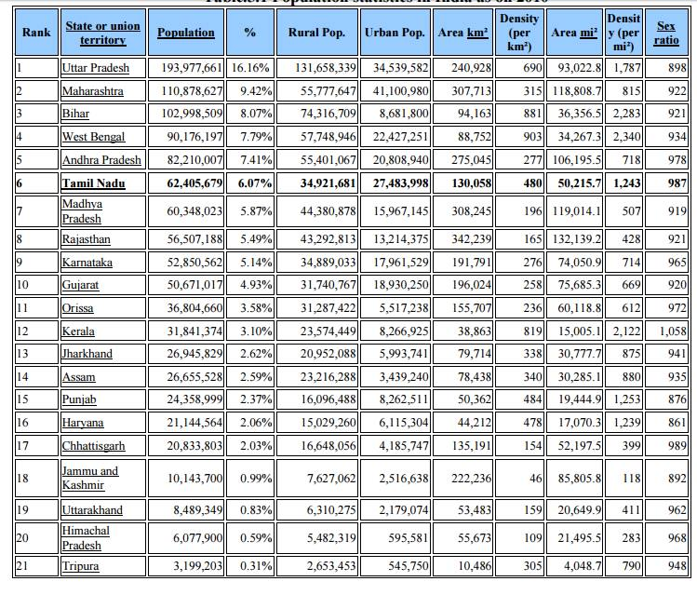

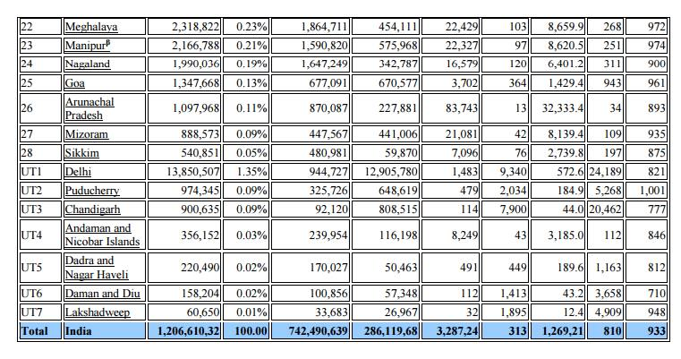

**1.4 Causes of rapid population growth**

* + - The rapid population growth is due to decrease in death rate and increase in birth rate.
    - Availability of antibiotics, immunization, increased food production, clean water and air decreases the famine-related deaths.
    - In agricultural based countries, children are required to help parents in the field that is why population increases in the developing countries.

**1.5 Characteristics of population growth**

* + - Exponential growth
    - Doubling time
    - Infant mortality rate
    - Total fertility rate
    - Replacement level
    - Male/female ratio
    - Demographic transition.

**1.6 Variation of population based on age structure**

2.     Pyramid shaped – India, Bangladesh, and Ethiopia.

3.     Bell shaped – France, USA, and UK.

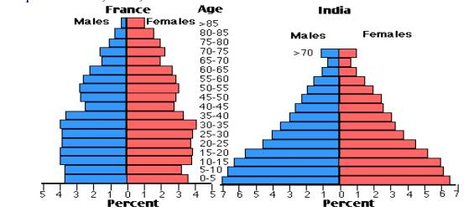

**Bell and Pyramid shaped Population structure**

3.  Urn shaped - Germany, Italy, and Japan.

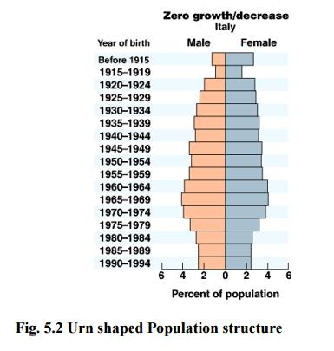

**1.7 Population Explosion**

The enormous increase in population due to low death rate and high birth rate.

**1.8 Causes**

Modern medical facilities, life expectancy, illiteracy.

**1.9 Effects**

Poverty, Environmental degradation, over –exploitation of natural resources, threat, communal war.

**1.10 Remedy**

Through birth control programs.

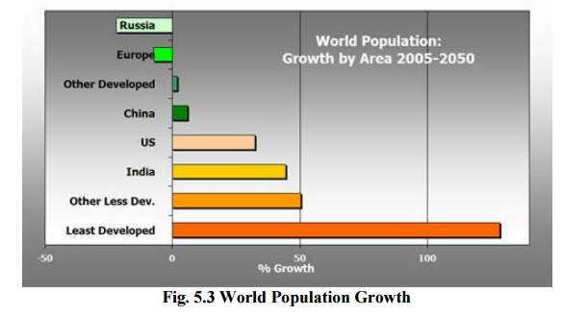

**2 FAMILY WELFARE PROGRAMME**

**2.1 Objectives**

o Slowing down the population explosion

o Over exploitation of natural resources

**3 FAMILY PLANNING PROGRAMME**

**3.1Objectives**

o Reduce infant mortality rate. o Encourage late marriages.

o  Improve women’s health.

o  Control of communal diseases.

1.     Physical Hazards – Radioactive and UV radiations, Global warming, Chlorofluro carbons, Noise etc.

2.     Chemical Hazards – Combustion of Fossil fuels, industrial effluence, pesticides, heavy metals.

3.     Biological Hazards- Bacteria, Viruses, Parasites.

**5 HUMAN RIGHT**

* Human right to freedom
* Human right to property
* Human right to freedom of religion
* Human right to culture and education
* Human right to constitutional remedies
* Human right to equality
* Human right against exploitation
* Human right to food and environment
* Human right to good health.
* To promote interdependence among Asian countries in all areas of cooperation by identifying Asia's common strengths and opportunities which will help reduce poverty and improve the quality of life for Asian people whilst developing a knowledge-based society within Asia and enhancing community and people empowerment;
* To expand the trade and financial market within Asia and increase the bargaining power of Asian countries in lieu of competition and, in turn, enhance Asia's economic competitiveness in the global market;
* To serve as the missing link in Asian cooperation by building upon Asia's potentials and strengths through supplementing and complementing existing cooperative frameworks so as to become a viable partner for other regions;
* To ultimately transform the Asian continent into an Asian Community, capable of interacting with the rest of the world on a more equal footing and contributing more positively towards mutual peace and prosperity.

**6 VALUE EDUCATION**

**Education**

 It is nothing but learning about the particular thing through knowledge. We can identify our values and ourselves with the help of knowledge and experience.

**6.1Types**

1. Formal education-Self related learning process.

2. Value education – Analyze based on instruments.

3. Value-based environment education- Based on environment.

**6.2 Objectives**

üTo improve the integral growth of human begins.

üTo create attitudes and improvement towards sustainable lifestyle.

üTo increase awareness about our national history our cultural heritage, constitutional rights, national integration, community develo9pment and environment.

üTo create and develop awareness about the values and their significance and role.

üTo know about various living and non- living organisms and their interaction with environment.

**6.3 Types of values**

vUniversal values-Importance of the human conditions.

vCultural values-Right, wrong, good and bad.

vIndividual values-Individual personality and experiences.

vGlobal values-Human civilization.

vSpiritual values-Self-restraint, discipline.

**7 HIV /AIDS**

AIDS is the abbreviated form for **Acquired Immuno Deficiency Syndrome** caused by a virus called HIV (**Human Immune deficiency Virus**).

**7.1 Origin of HIV/AIDS**

1.     Through African Monkey

African monkey or Chimpanzees To human.

2.     Through Vaccine Program

(a)Polio, small pox vaccine from monkey’s kidney-Africa.

(b) Hepatitis-B viral vaccine-Los Angles and New York.

**7.2 Factors influencing modes of Transmission of HIV**

1. Unprotected sex with infected person.

2. Using needles or syringes from HIV positive person.

3. During pregnancy, breast feeding HIV transmits from mother to infant babies.

4. Blood transfusion during accident and pregnancy.

5. Biologically the male to female transmission is 2 to 4 time more efficient than female to male transmission.

6.   Women’s cervical tissue is more vulnerable to HIV than men.

**7.3 Factors not influencing transmission of HIV**

1. Tears, food, air, cough, handshake and normal kissing.

2. Mosquito flies and insect bites.

3. Sharing of utensils, clothes, toilets and bathroom.

**Effects**

·        Death

·        Loss of labor

·        Inability to work

·        Lack of energy.

**7.4 Functions of HIV in human body**

White blood cells (WBC) are responsible for the formation of antibodies called T-helper cells’-helper cells are the key infection fighters in the immune system. Once HIV cells are enter into the boy they destroy the T-cells and cause many infection diseases.

7.5**Symptoms**

**I. Minor symptoms**

üPersistent cough for more than one month.

üGeneral skin disease.

üViral infection.

üFungus infection in mouth and throat.

üFrequent fever, headache and fatigue.

**II.**               **Major symptoms**

üDiarrhea for more than one month.

üTB for more than one month.

üFall of hairs.

ü10% of body weight loss within short period.

**7.6 Mechanism of Infection**

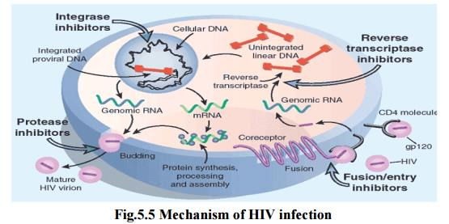

**7.7 Control and Preventive measures**

1.     Education.

2.     Prevention of Blood borne HIV transmission.

3.     Primary health care.

4.     Counseling services.

5.     Drug treatment.

**7.8 Scenario in India**

Large number of cases has been reported in Maharashtra and Tamil Nadu.

**7.9 World Scenario**

Nearly 90% of the HIV affected peoples live in developing countries.13% of world’s population live in Africa. About 3 million people so far died due to HIV in 2003.In the world AIDS ranking India is in 2nd place.

**8 WOMANS AND CHILD WELFARE**

**5.8.1**    **Objectives**

vTo provide education

vTo impart vocational training

vTo generate awareness

vTo improve employment opportunities

v   To restore dignity, equality and respect.

**9 ROLE OF INFORMATION TECHNOLOGY IN ENVIRONMENT**

**1. Remote sensing**

Components - A platform, aircraft, a balloon, rocket and satellite.

**Functions**

·        Origin of electro magnetic energy

·        Transmission of energy

·        Interaction of energy

·        Detection of energy

·        Preprocessing of data

·        Data analysis and interpretation

·        Integration and other applications.

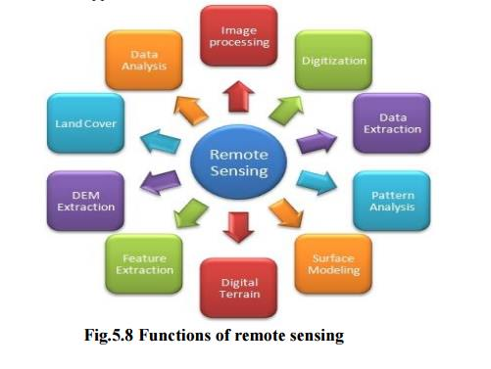

**Applications**

In agriculture, forestry, land cover, water resources.

**2. Data Base**- Collection of inter related data on various subjects.

**Applications**

§Ministry of environment and forest

§National management information system

§Environmental information system.

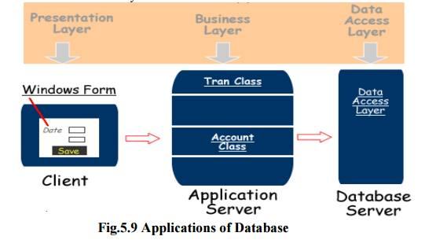

**3. Geographical information system (GIS)**

It is a technique of superimposing various thematic maps using digital data on a large number of inter-related aspects.

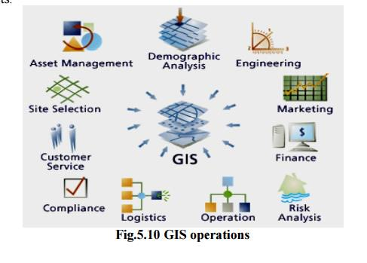

**Application**

ØThematic maps are super imposed using soft wares.

ØInterpretation of polluted zones

ØTo check unplanned growth and related environmental problems.

**4.** **Satellite data**

v   Helps in providing reliable information and data about forest cover

vProvide information about forecasting weather

vReserves of oil, minerals can be discovered.

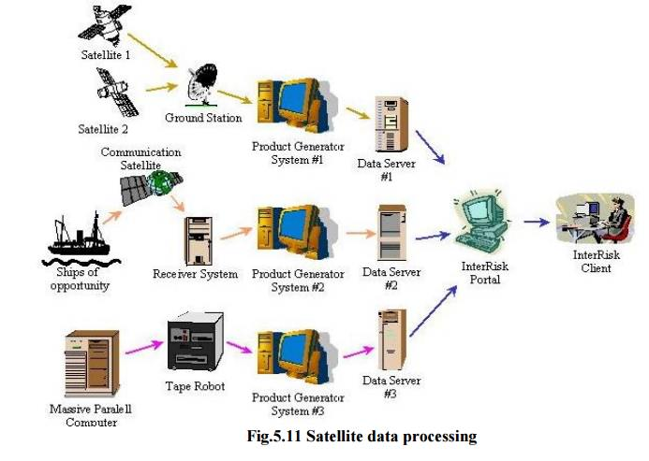

**5. World Wide Web**

It provides **Current data**.

**Applications**

·        Online learning

·        Digital files or photos, animations on environmental studies.

**10 ROLE OF INFORMATION TECHNOLOGY IN HUMAN HEALTH**

The health service technology involves three systems Ø Finance and accounting

Ø Pathology

Ø Patient Administration – clinical system.

**Applications**

§ Data regarding birth and death rates

§ To monitor the health of the people effectively

§ The information regarding the outbreak of epidemic diseases.

§ Online Consultation

§ Drugs and its replacement.